



Fundamentals Of Data Science
Assignment 1 Documentation

SUBMITTED BY
Pawan Gyawali
STUDENT ID: 26008001
SECTION A
THE BRITISH COLLEGE

Program 1: Arithmetic Calculator
Program Description
Program File: q1_sum_difference.py
Purpose: Does simple arithmetic operations of two numbers typed in by the user.
This program will ask the user to input two integer numbers and then perform and show four arithmetic operations which are sum, difference, product and quotient. It can deal with edge cases like division by zero, showing Undefined (division by zero) rather than throwing an exception. The program has a strong input validation, that is, a loop, which re-prompts the user in case of invalid (non-integer) input.
Key Features •
- Take two integer inputs through complete input checks.
Computers: Sum, difference, product, and quotient.
- Beautifully resolves the division by zero - will show "Undefined" rather than crash.
- Separated lines in a clear formatted output.
Testing Screenshots
The screenshot below demonstrates the program running with sample integer inputs (e.g., 10 and 3), showing all four arithmetic results. A second test with a zero divisor demonstrates the division-by-zero safeguard.
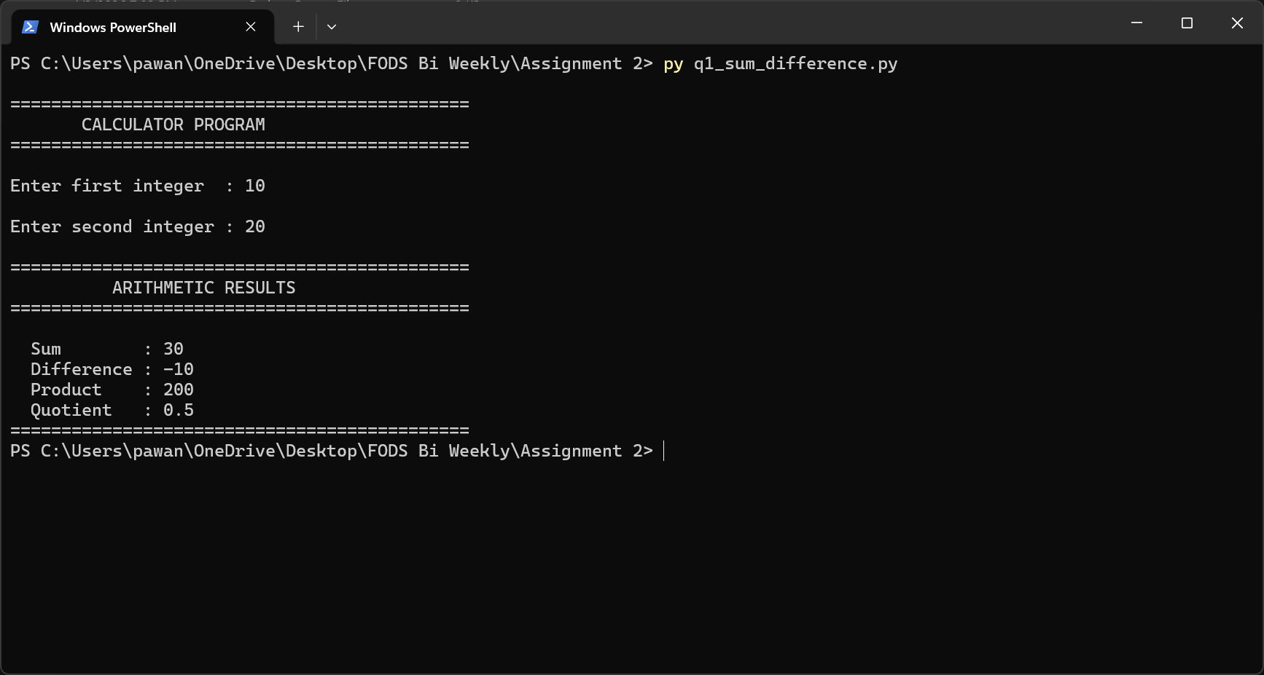
Figure 1.1 – Program 1 execution: arithmetic operations on two integers

Program 2: Mathematical Functions
Program Description
Program File: q2_math_functions.py
Purpose Demonstrates modular programming by having five math operations as independent functions.
This program is a mathematical program that uses five different mathematical operations that are in turn another function addition, multiplication, division, floor division and exponentiation. The user types in two numbers (floats are accepted) and the five results are calculated and presented as a formatted table. Both division and floor division have zero-divisor guards. The design also focuses on code reusability - each of the functions is callable on its own and thus the program becomes easy to test or extend.
Key Features
- Five separate functions: addition(), multiplication(), division(), floor_division(), exponentiation()
- Takes floating-point numbers to be more flexible. •
- Division to 2 decimal places. • Both division functions have a zero-divisor protection.
- top-level try/except block gracefully accepts non-numeric input.

Testing Screenshots
The screenshot below shows two test runs: one with positive floats (e.g., 7.5 and 2.0) and one with a zero as the second operand to verify the division guard.
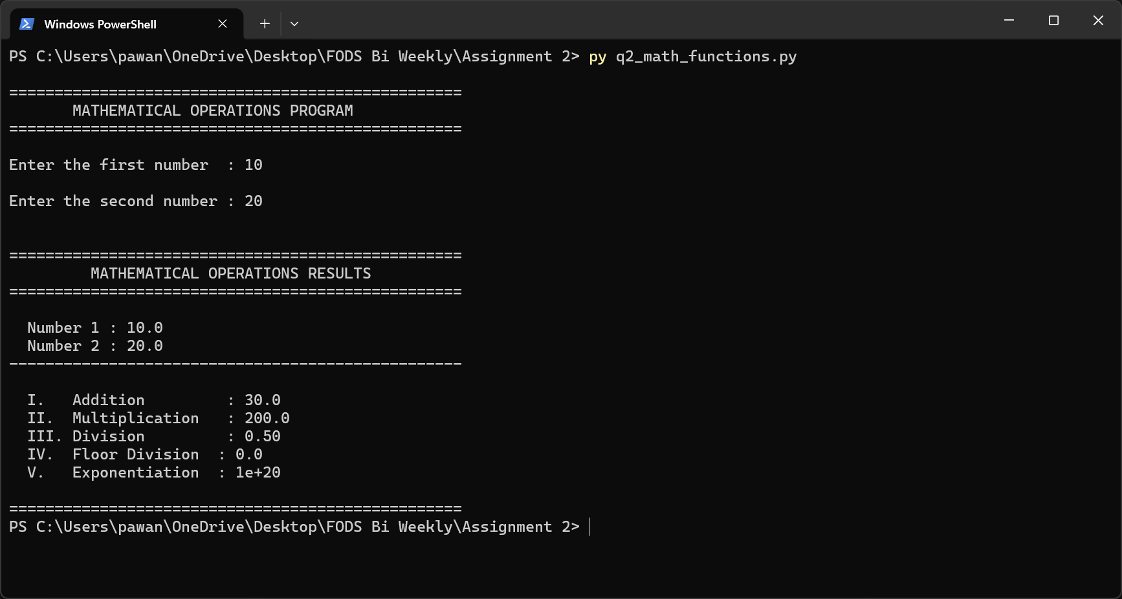
Figure 2.1 – Program 2 execution: five mathematical operations with sample inputs

Program 3: Armstrong Number Checker
Program Description
Program File: q3_armstrong_checker.py
Purpose: Checks to see whether a number is an Armstrong (narcissistic) number.
An Armstrong number is a number that is equal to the sum of the digits of that number raised to the power of the total number of digits. For example, 153 = 1³ + 5³ + 3³ = 153. The user inputs a string to this program, which is then changed into an integer and each digit is extracted, multiplied to the relevant power and the result is compared to the input number to verify whether the numbers are the same. The is armstrong() function will be returning a Boolean that will be presented using explicit YES/NO messages.
Key Features
- Divides Armstrong numbers of any number of digits (not only 3-digit)
- The input comes in the form of a string to be processed digit by digit.
- try/ except within is armstrong avoids crashing on non-numeric input.
- Pass/fail result message with the number being tested returned back.
Testing Screenshots
The screenshot demonstrates testing with multiple inputs: a known Armstrong number (e.g., 153 or 370), a known non-Armstrong number, and a multi-digit case to verify generality.
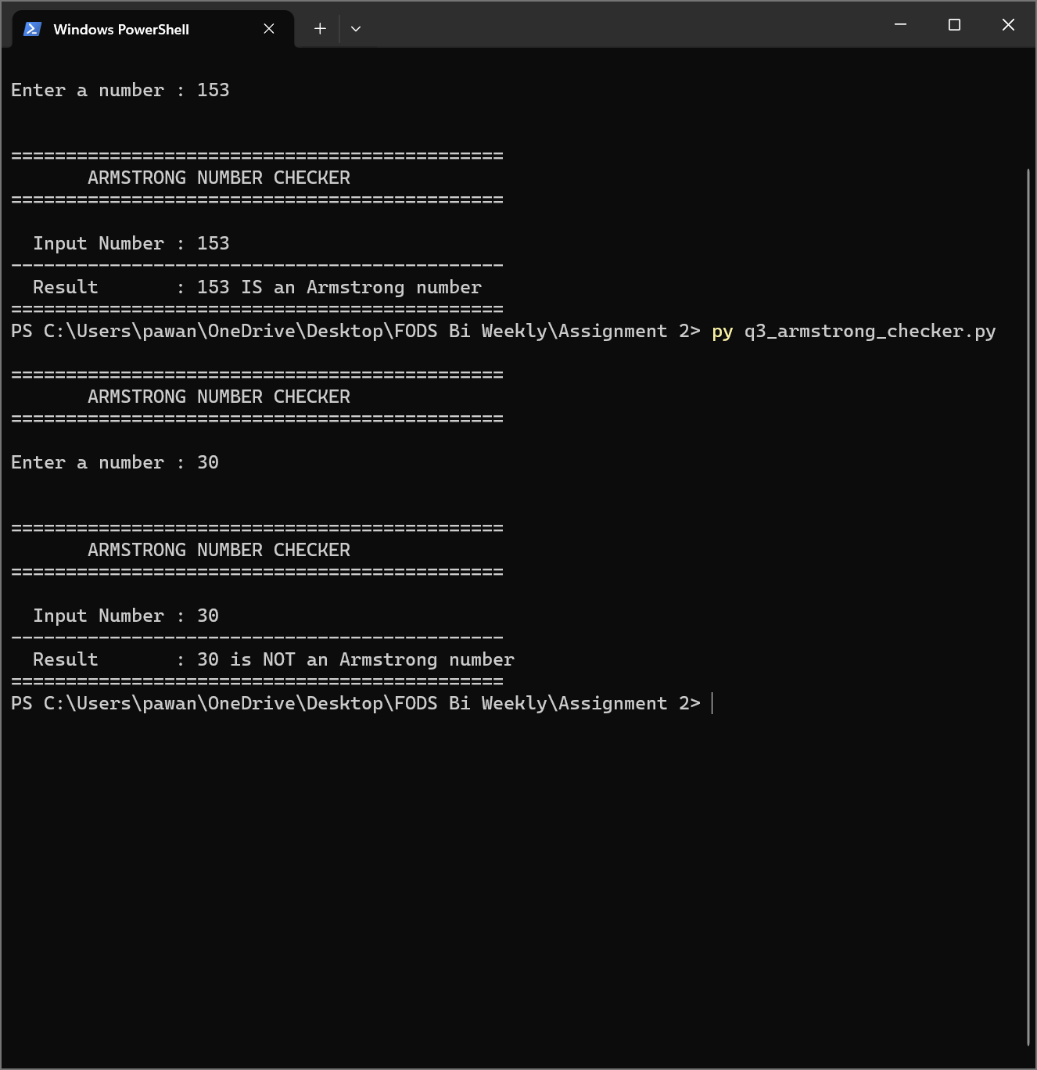
Figure 3.1 – Program 3 execution: Armstrong number checks with multiple test inputs

Program 4: Frequency Dictionary
Program Description
Program File: q4_frequency_dictionary.py
Purpose: Constructs a frequency dictionary of the number of times a number appears in a list.
The program illustrates the construction of the dictionaries, using a loop through a list of numbers and counting the number of times each number is repeated. The basic frequency dictionary () procedure applies a simple counter scheme: when the key appears, add 1 to it; when not, create it with 1. The program is also coded with three test lists that are predefined to clearly demonstrate the behaviour of the function under different inputs, and thus it is easy to have the graders confirm the correctness of this program, without entering the data manually.
Key Features
- frequency-dictionary This is a dictionary of counts of each number: frequency-dictionary()
- Three test cases that are built in and cover: repeated elements, heavily repeated values and all-unique values.
- Outputs the original input list and the resulting frequency dictionary.
- Clean readable format with separators between test cases.

Testing Screenshots
The screenshot shows all three test cases running in sequence, with the input list and resulting frequency dictionary displayed for each.
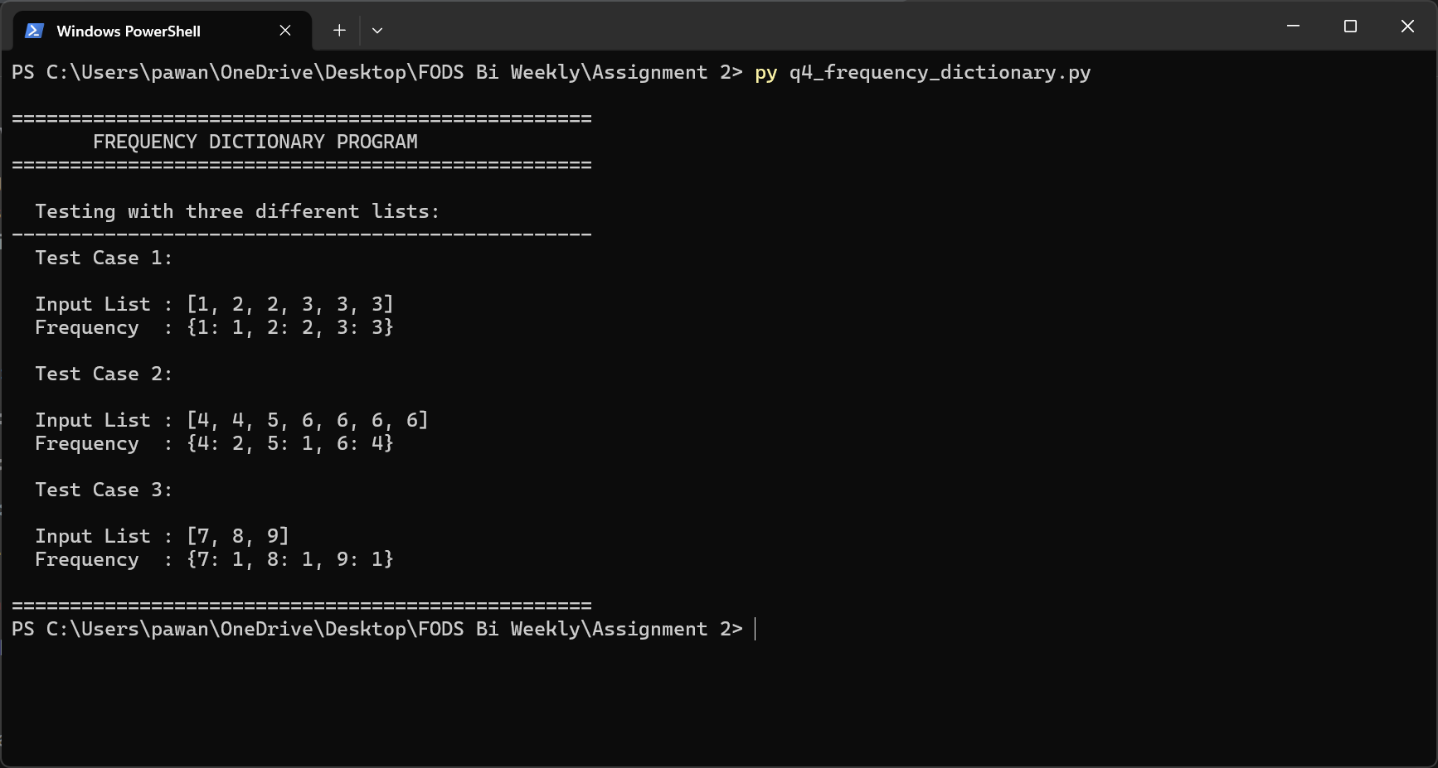
Figure 4.1 – Program 4 execution: frequency dictionary for three test list

Program 5: Reverse Alphabetical Sort
Program Description
Program File: q5_reverse_sort_names.py
Purpose: Gathers the names of the students using user input and arranges them in reverse alphabetical order.
This program requests the user to type in the number of student names to be entered and then one name at a time is gathered. After collecting all the names, the sort-names-reverse() function is used to reverse-alphabetically sort the names by calling the Python built-in sorted(reverse=True). The result (sorted) and the original unsorted list are printed next to each other so they can be easily compared. The get ordinal suffix helper gives amiable ordinal suffix (1st, 2nd, 3rd.) when entering names.
Key Features
- Dynamic input: user enters any number of names of students.
- Ordinal suffixes (1st, 2nd, 3rd, 4th.) to be applied to intuitive cues.
- Input validation: It is checked that a positive integer is typed in count.
- Original and sorted lists were presented to allow a direct comparison.
- Uses Python sorted (reverse= True) - no sorting logic needed.
Testing Screenshots
The screenshot shows the program collecting names interactively and then displaying the original and reverse-sorted lists side by side.
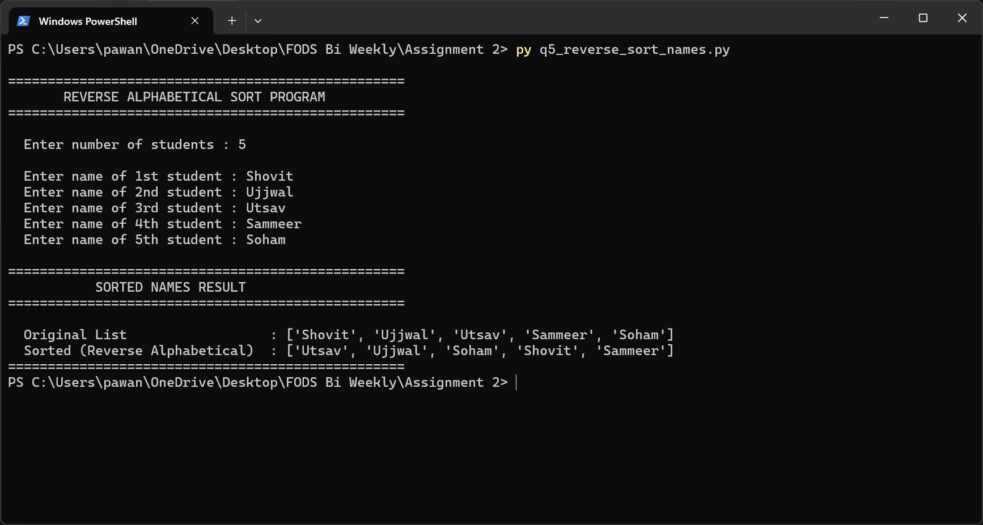
Figure 5.1 – Program 5 execution: names entered and sorted in reverse alphabetical order

Program 6: Country Search
Program Description
Program File: q6_country_search.py
Purpose: Search the user-defined list of the countries and get the index of the desired country.
This program enables the user to create a list of country names and afterwards, the user can search a certain country in that list. The search country () function is used to determine the existence of the target country by the in operator in Python and the found country index will be returned by the list.index() operator. In the event the country is not located, it gives back the constant string "Not Found in List". Input checks make sure that the number of countries is a positive integer. The result is a reflection of the word being searched and it indicates the result.
Key Features
- User creates a personalized list of any size of countries on-the-fly.
- Searching Python in operator and list.index() case-sensitively.
- Return 0 based index on a hit, or a description "Not Found" message.
- Not found message is always constant, so that it is easy to modify the no-result string.
- Input validation loop: invalid (non-positive) counts are avoided.

Testing Screenshots
The screenshot demonstrates two scenarios: a successful search returning the index position, and a search for a country not in the list returning "Not Found in List".
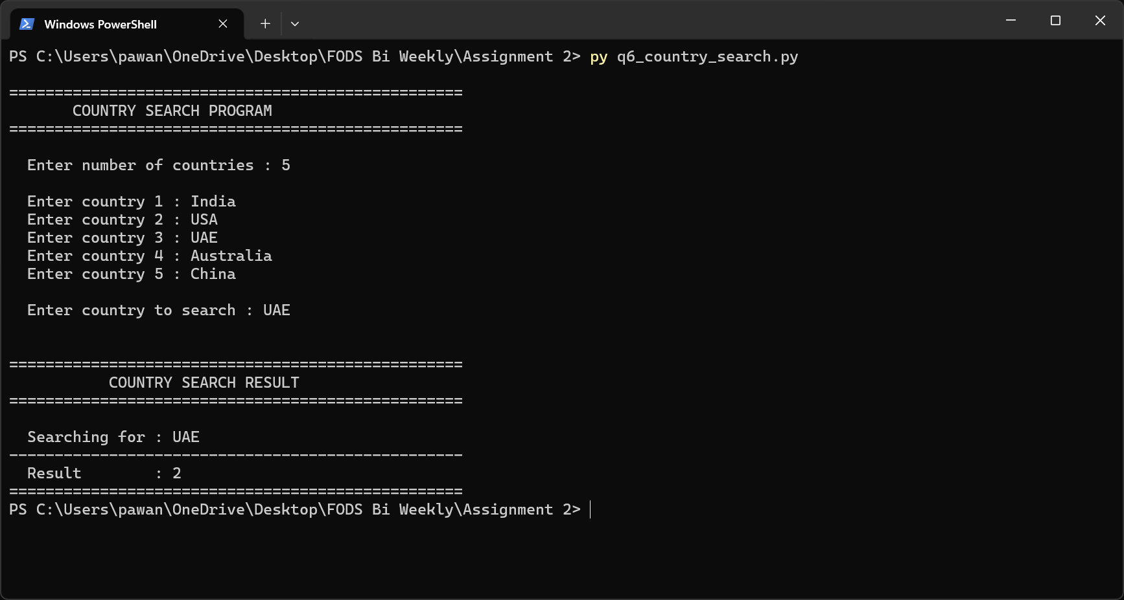
Figure 6.1 – Program 6 execution: country found (with index) and country not found

Program 7: Character Frequency Counter
Program Description
Program File: q7_character_frequency.py
Purpose: Tally the number of times a character occurs within a sentence that is entered by the user. This program takes a sentence as input and gives out a character frequency dictionary. To count insensitively to case and whitespace removal, the sentence is first changed to lowercase with the key_value() function, which removes any spaces in the sentence. Every non-space character is replaced by a key of the dictionary whose value is the number. The results are presented in alphabetical order, which can be easily verified and each character along with its frequency is presented on a separate line.
Key Features
- Case-insensitive counting - upper and lower case letters are the same.
- Spaces not counted in the frequency.
- Output of results (alphabetically by character) to be able to read the results consistently.
- Other works with any sentence containing punctuations and numbers.
- The key-value() function is reusable and self-contained.

Testing Screenshots
The screenshot shows the program processing an input sentence and displaying the sorted character frequency dictionary, clearly demonstrating case folding and space exclusion.
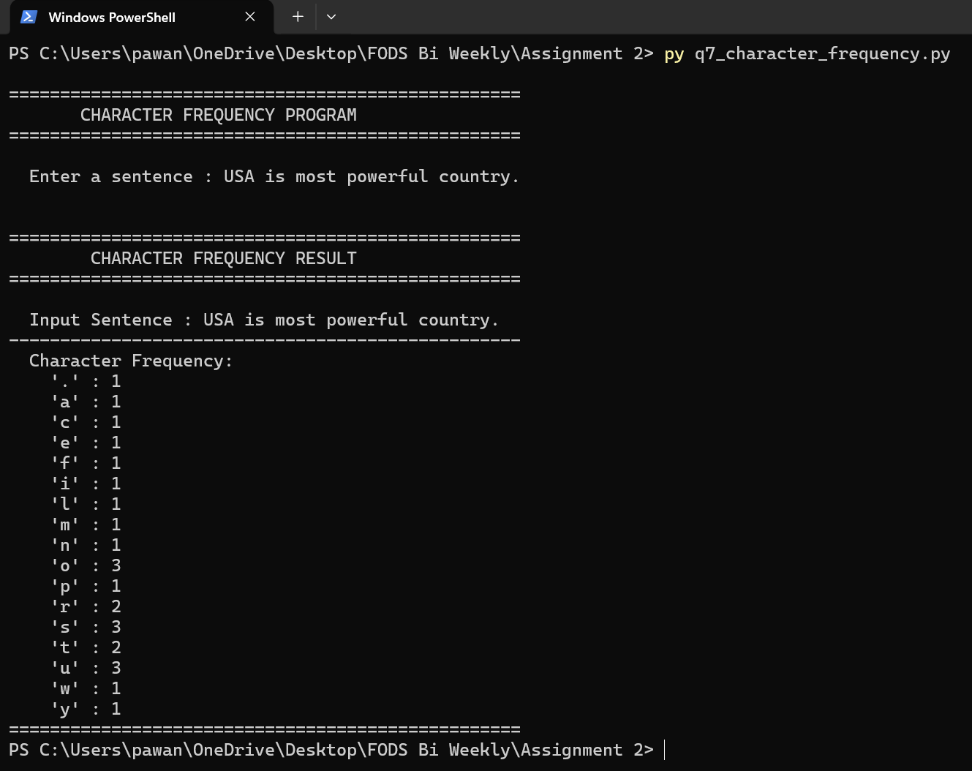
Figure 7.1 – Program 7 execution: character frequency for a sample sentence

Program 8: Remove Duplicates & Sort

Program Description
Program File: q8_remove_duplicates_sort.py
Purpose: Eliminates any duplicates in a list and provides the rest of the values in ascending order. In this program, the user is allowed to enter a space-separated sequence of integers and the program will remove all duplicated values and return the unique values in an ascending order. This can be done succinctly with the remove_duplicates_and_sort() function with sorted(set(numbers)) which converts the numbers into a set, which removes duplicates and sorted rearranges the set. The program justifies the fact that no fewer than one number is typed in to continue. The original (unsorted, with duplicates) and the processed list are provided in order to compare them.
Key Features
- Single-line core logic: sorted(set(numbers)) - concise, Pythonic.
- User types the numbers in between spaces - no commas or formatting needed.
- Deals with input of no value smoothly with a suitable error message.
- Shows original list and deduplicated/sorted result next to each other.
- map(int, input.split()) to clean lists, which were used to construct integers.
Testing Screenshots
The screenshot demonstrates the program with a list containing multiple duplicates (e.g., 5 3 1 3 5 2 1), clearly showing the duplicates removed and the remaining values sorted.
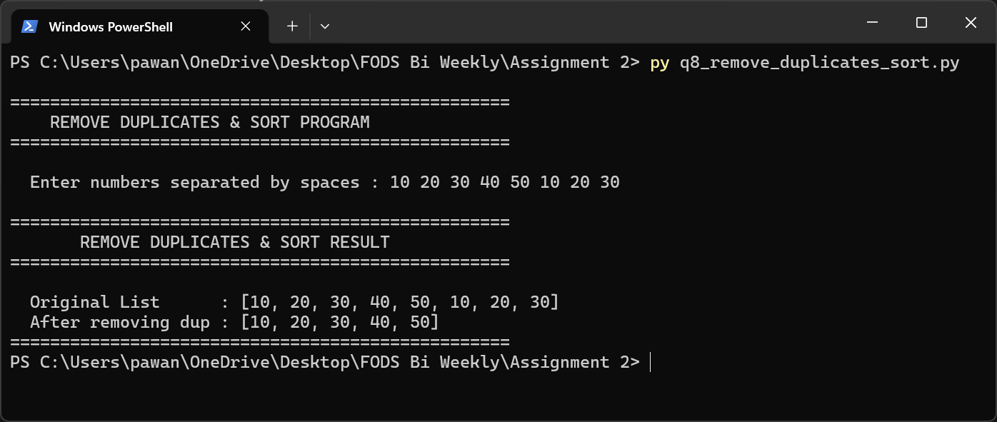
Figure 8.1 – Program 8 execution: duplicates removed and values sorted ascending

Program 9: Movie Details Manager

Program Description
Program File: q9_movie_dictionary_sort.py
Purpose: Gathers movie information into dictionaries and portrays this information in a structured format. This program handles a set of movie records. The program gathers four attributes (title, director, release year, and rating 010) of every movie the user specifies. The movies are stored as a dictionary in a list. Specialized helper functions do the input validation: get_valid_year() is used to ensure that the year is a numeric digit-string, and get_valid rating is used to ensure that the rating is a 0-10 float. Every movie is then shown in a well-formatted summary, one movie per block.
Key Features
- Allows an arbitrary number of movies to be entered at run time.
- Every movie in the form of dict: title, director, year, rating.
- Individual validation procedures of year (integer) and rating (float 0 -10).
- Rating is shown to the decimal point to have a uniform format.
- Films in a row with visible per-film separation lines.

Testing Screenshots
The screenshot shows the program collecting details for multiple movies with varied ratings and years, then displaying the formatted movie list.
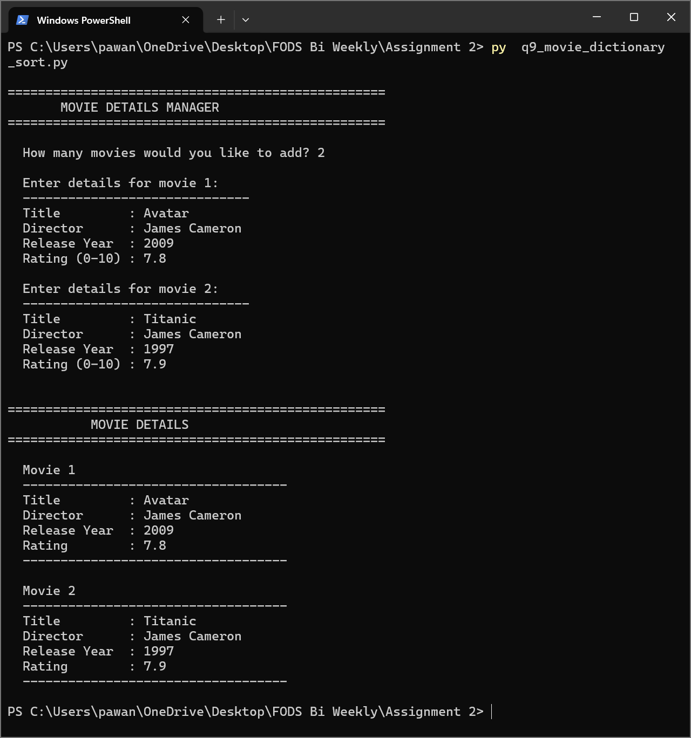
Figure 9.1 – Program 9 execution: movie detail entry and formatted display

Program 10: Dice Guessing Game

Program Description
Program File: q10_dice_game.py
Purpose: This is a simulation of a dice guessing game, in which the player attempts to guess a randomly rolled value. This is an interactive game that involves the rolling of a six sided dice. The program will generate a value of a dice with random.randint(1, 6), followed by the player being asked to guess. The display result() evaluates the guess: a perfect match presents a winning smiley face, a guess that is off by exactly 1 presents a neutral face that represents a near-miss, and as any other guess presents a losing frown. The int() conversion in the get_user_guess() is placed in a try/except block to ensure that the non-numeric entries do not crash the program.
Key Features
- Simulates a fair, unbiased dice with random.randint(1, 6).
- Three possible results: perfect (win), 1 off (near miss), incorrect (loss)
- Result output emoji faces give prompt feedback.
- The use of try/except in get_user-guess avoids crash on invalid input.
- --Multiple functions: roll dice, get user guess, display result are distinct functions.

Testing Screenshots
Two screenshots below demonstrate both possible result states: a correct guess (win) and a wrong guess (loss), verifying all result branches work correctly.
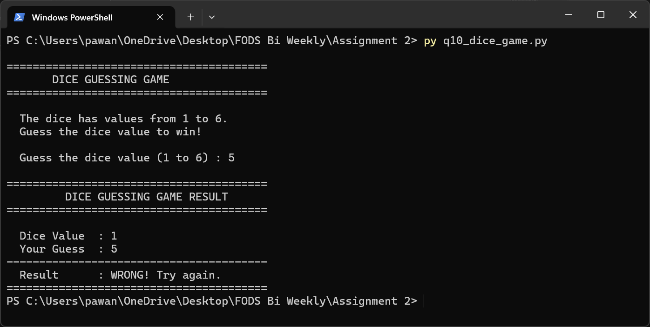
Figure 10.1 – Program 10: incorrect guess result (wrong answer scenario)
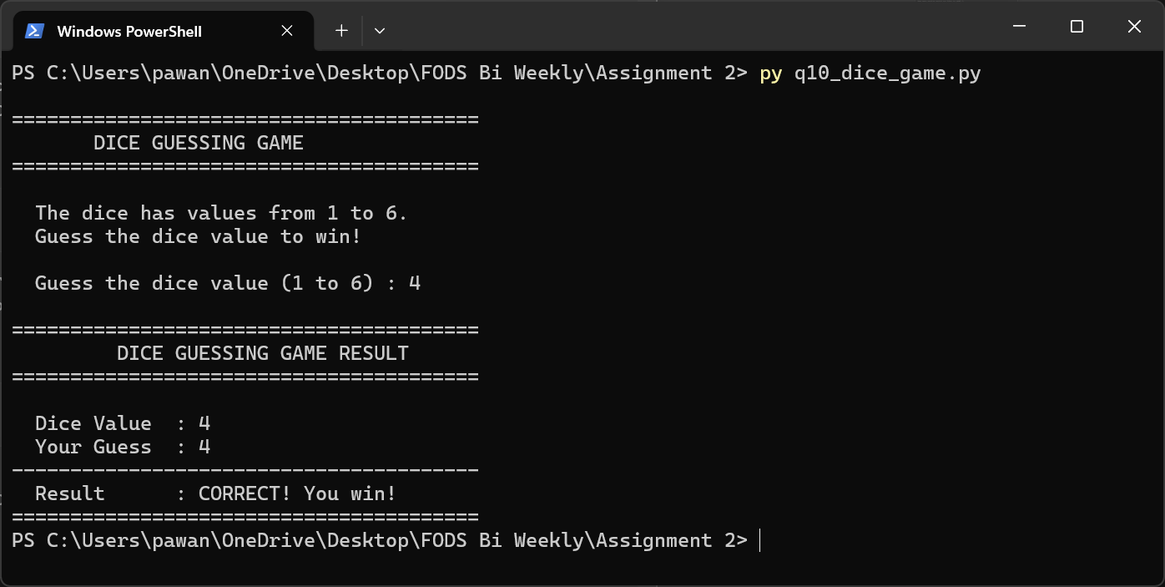
Figure 10.2 – Program 10: correct guess result (winning scenario)

